March 3, 2023

When our team goes through the list of potential gaps for Web PD vs Desktop PD related to CSHS/BUE, we came across this Aha idea IWF-I-556 Web Designer has incorrectly-sized code editor window on first load | Aha!

Our team has kindly try to get the BPM on Cloud env and follow the steps in the Aha idea, and the conclusion is that this issue does not exist anymore in the latest version of BPM on Cloud. So, when customer moves up to the latest version of BPM on Cloud, this problem should not exist anymore.

This was tested with Windows 10 Enterprise, Chorme 110.0.5481.105.

Step 1, Open Work dashboard via https://bawdemo01.bpm.ibmcloud.com/dbaoc/portal/index.jsp?ui_style=2020.10#/work
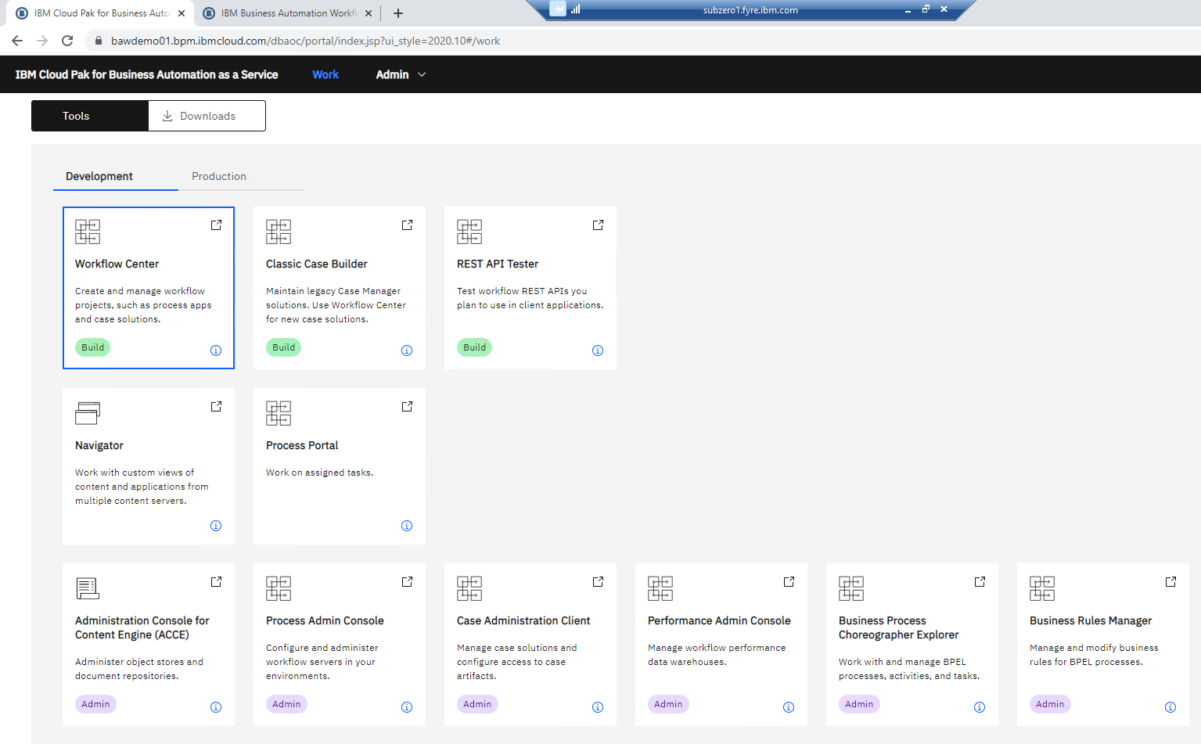
Step 2, Note that "Process Center is not made available in the BAWoC landing page anymore as that shows Workflow Center in the meantime, but the old UI can still be opened directly https://bawdemo01.bpm.ibmcloud.com/baw/dev/ProcessCenter", So I just opened a new tab with ProcessCenter URL.
Step 3 to Step 4 able to follow:
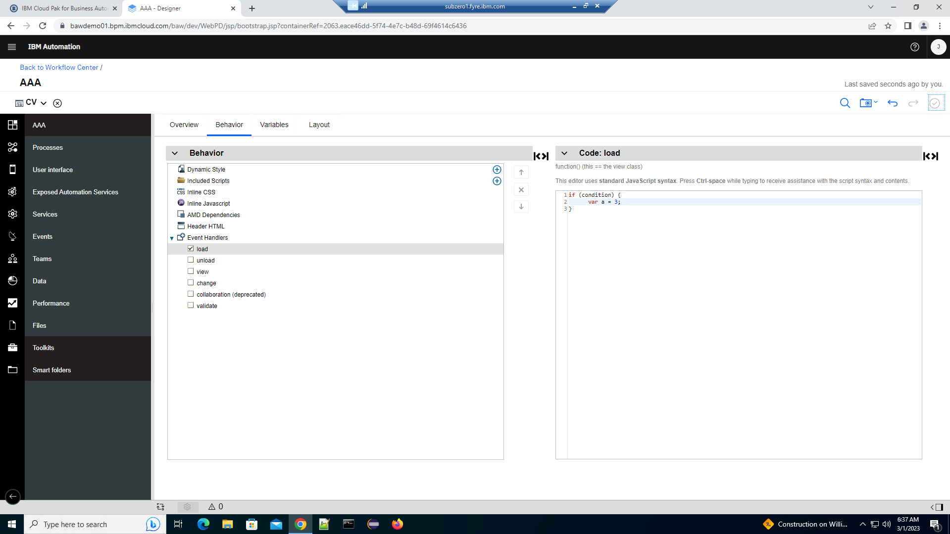

Step 5, after 24 hours, I do see "Error connecting to server" which means user session expired. Looks to me the session won't expire within 24 hours, user has to wait 24 hours or more to see the red error at the bottom right corner. Also, the right Code:load window auto disappeared because Event Handlers: view was auto selected, not sure why (maybe because I reopened the VM?).
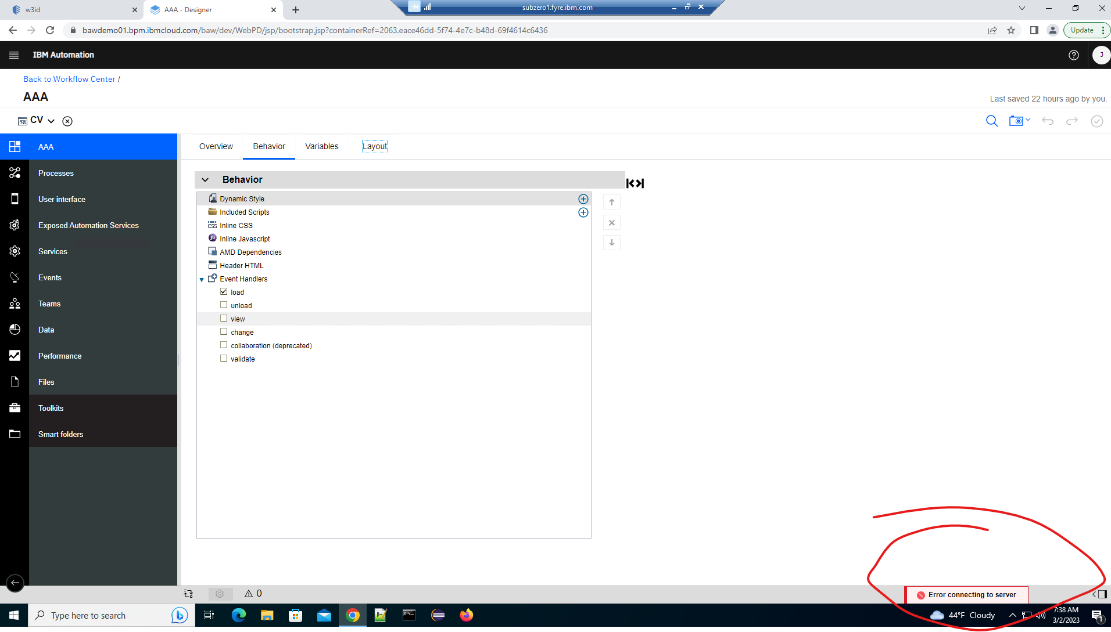
Step 6 is okay to follow. (I did above steps twice, due to w3id SSO outage on Feb 28, the first time test was not able to continue...), you will see the Work dashboard page asked me to login again. I didn't login from here because of step 7.
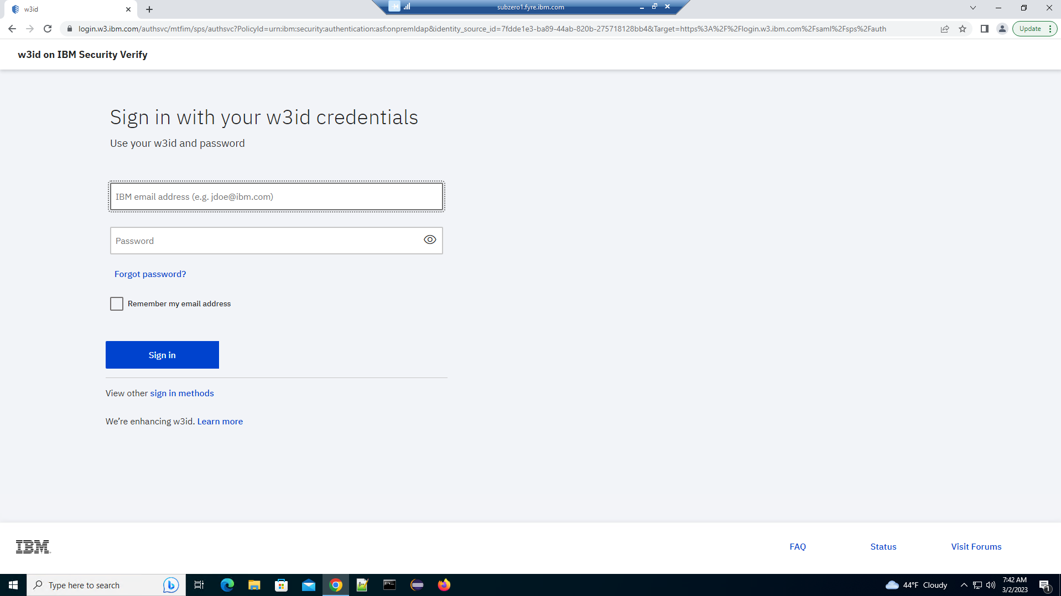

Step 7, reopen the Process Center from "Work" dashboard, this is not possible, reason is mentioned in Step 2, there is no more Process Center link in "Work" dashboard. So I opened a new tab and entered URL https://bawdemo01.bpm.ibmcloud.com/baw/dev/ProcessCenter, and used my w3id to login there.
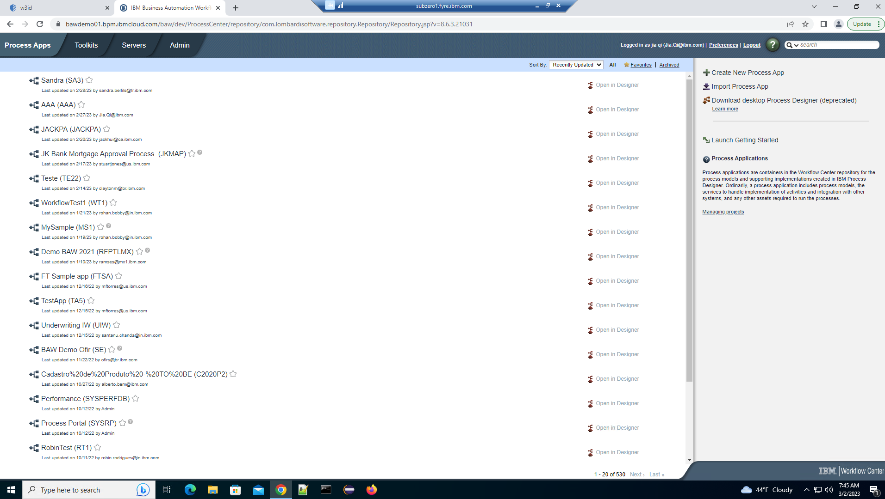

Step 8, Able to follow to reopen the Process App, but the coach view page with Behavior tab won't auto load as described in customer instruction, I have to navigate to there manually, and customer issue was not reproducible:
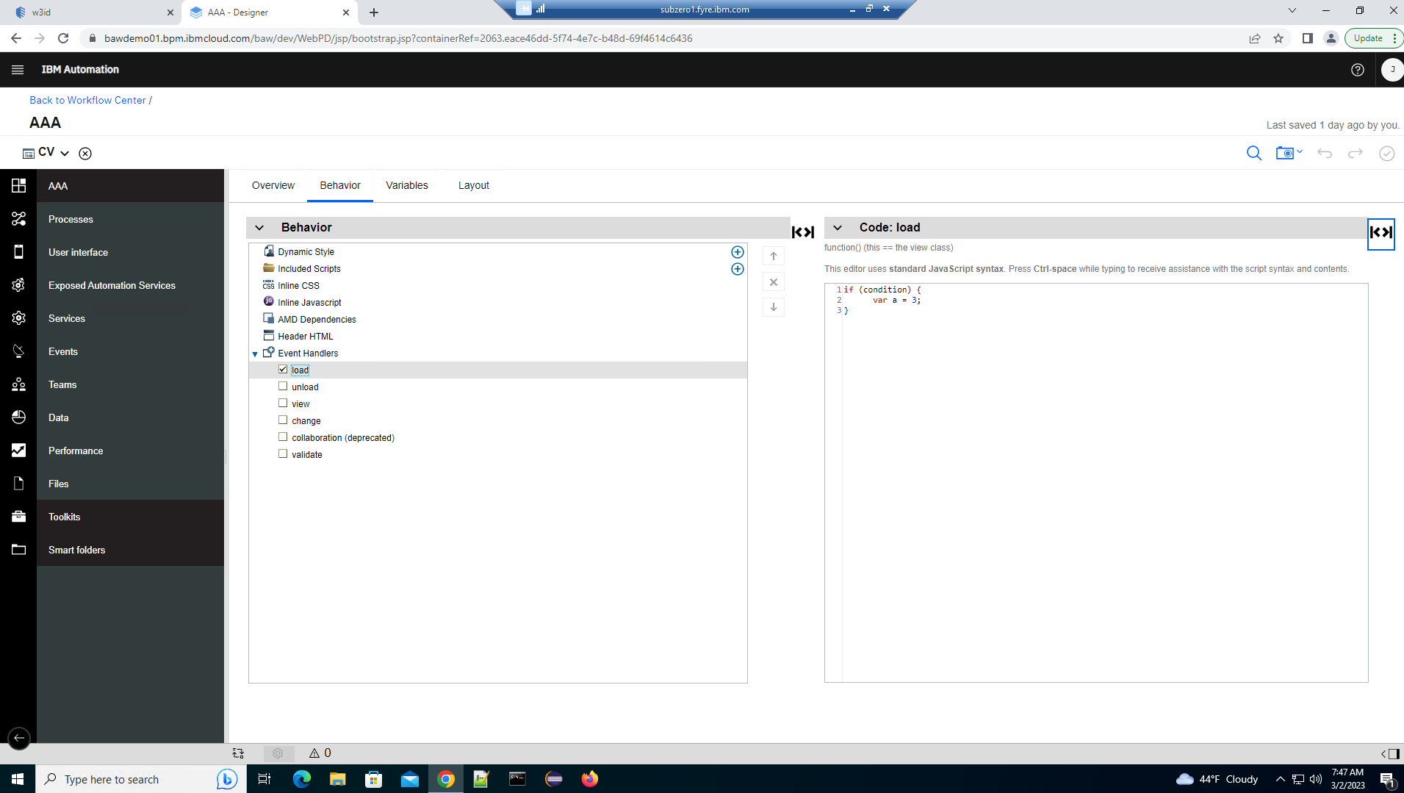
Conclusion:
Due to Process Ceter has been removed from Work dashboard, and the improvment or change for w3id SSO over the years, the cutomer issue can NOT be reproduced anymore.

