Feature Request:
WYSIWYG Mail Editor in IBM Content Navigator
Customer: | MTU Aero Engines AG

System overview
Content Engine : 5.5.4 FP2
Content Navigator : ICN 3.0.10 FP1
Windows Server : Windows Server 2016 Standard Edition
WebSphere : 9.0.0.9

Abstract Problem description
The mail editor in ICN supports only plain text, but the customer needs WYSIWYG functionality

Detailed Problem Description
A function frequently used by customers is sending emails directly from ICN.
Unfortunately, the mail client in ICN only supports PLAIN text. Formatting of emails is therefore not possible.
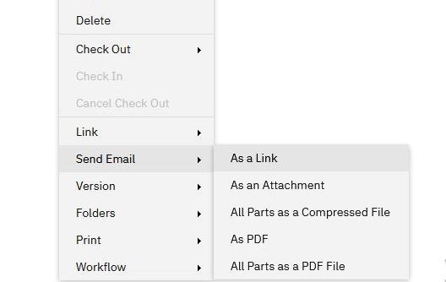

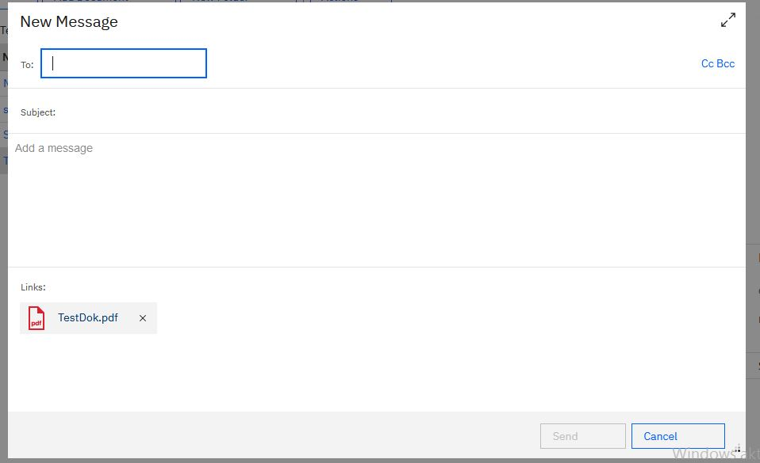

For the correspondence with the customer, however, formatting such as outlining, highlighting important information or inserting and marking quotes are an important part of the daily communication.
The customer therefore requests the enhancement of the ICN mail client with a WYSIWYG editor as it is now standard in other enterprise products.
As an example a screenshot of a possible solution is attached.
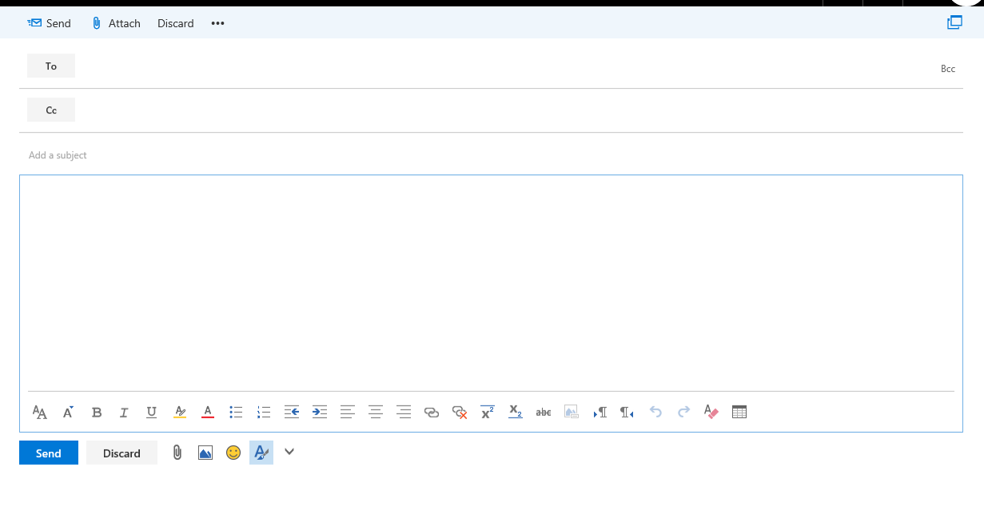

Expectation
Extend the mail client in ICN with a WYSIWYG editor

