Problem Statement:
Need help on automating human service execution using Java/ JS API/ REST API.

Example:
Below is the BPD and Human Service attached to it.
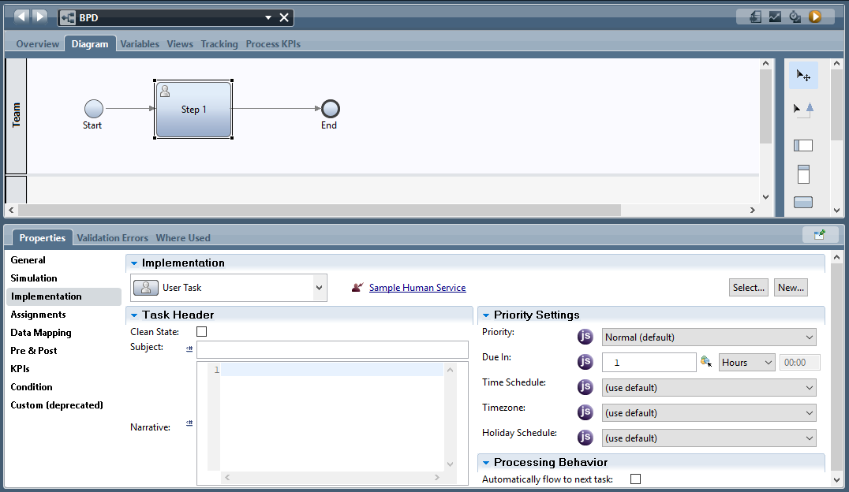

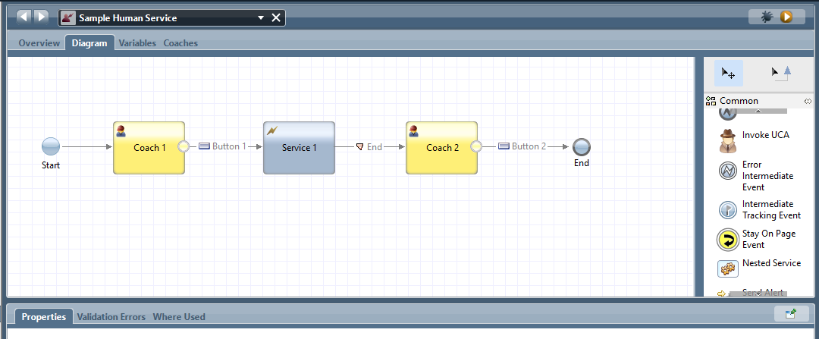

Consider we have one instance created with instance ID 518 with Task ID 518.
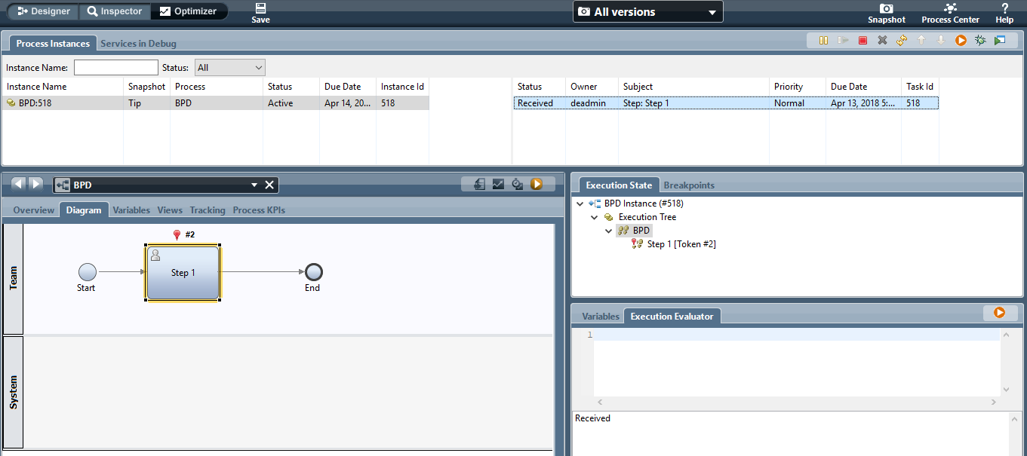

Question

Using a separate Integration Service, we want to automate task and complete it using Java Script API or Java or REST API.
In this example: We want to move task (Task ID 518) to move task in below order
- Start to Coach 1
- Coach 1 to Service 1 (Consider Service 1 gets failed first time)
- Service 1 to Coach 2 (Resume Service1 and move to Coach 2)
- Coach 2 to End
Please note that below APIs are working with Heritage Human Service & Heritage Coach.
When driving the task via a regular Human Service that contains coaches, use this call sequence:

When driving the task via a regular Human Service that contains coaches, we use this call sequence (REST API):

1. Task Details (TASK API)
2. Start Task (input data, plus initialization data up to the first coach, is visible at this point)
3. For each Coach encountered (Service API)
a. Get Data
b. Set Data
c. Resume Service (pass in Task ID and Button Action)
4. Finish Task (if task was not already completed by a previous call)

We need correct REST API to automate the Client Side and Heritage Human Service.
If the solution is available using Java, TW Java Script or REST API – We are fine to use it.

