Background:
We have an Integration with the IBM BPM System Version 8.5.7 and the IBM File Net System version 5.2.0.2 for managing the documents. All Folders created / documents uploaded into the BPM Application Screens get created/uploaded into File Net application using the Document Explorer control of the BPM. (Refer Fig 1.1 and Fig1.2).
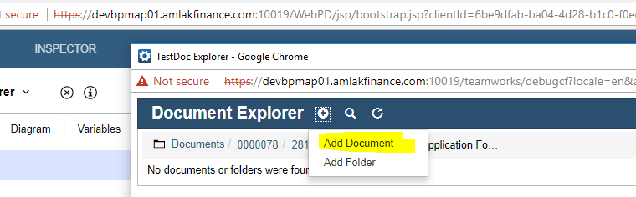

Fig 1.1
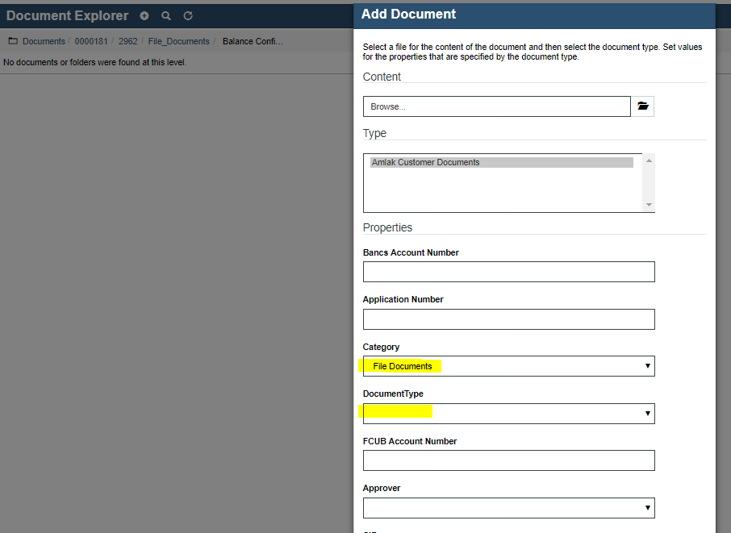
Fig 1.2
Issue
While attaching the documents, the User has to manually select the category (i.e. File Documents, Security documents) and thereafter select the Document type. There two drop downs are interlinked.However, The IBM BPM’s control Document Explorer control does not make these two drop downs interlinked. This creates Issues as Users sometime select a wong document type for a particular category

Requirement:
We need the Category and Document Type Drop Downs to be Inter linked.(The values can be static defined but the two drop downs need to be linked. i.e for Category =”File Documents” only those list of Items linked to File Documents should be listed in the Document Type drop down.

